**Overview of Generative AI**

* Introduction to GenAI
* GenAI Response Formats
* What GenAI can do?
* Key Technologies behind GenAI
* Applications of GenAI
* History and Evolution
* Challenges of GenAI

****Introduction to Generative AI (GenAI)****

**History of GenAI**

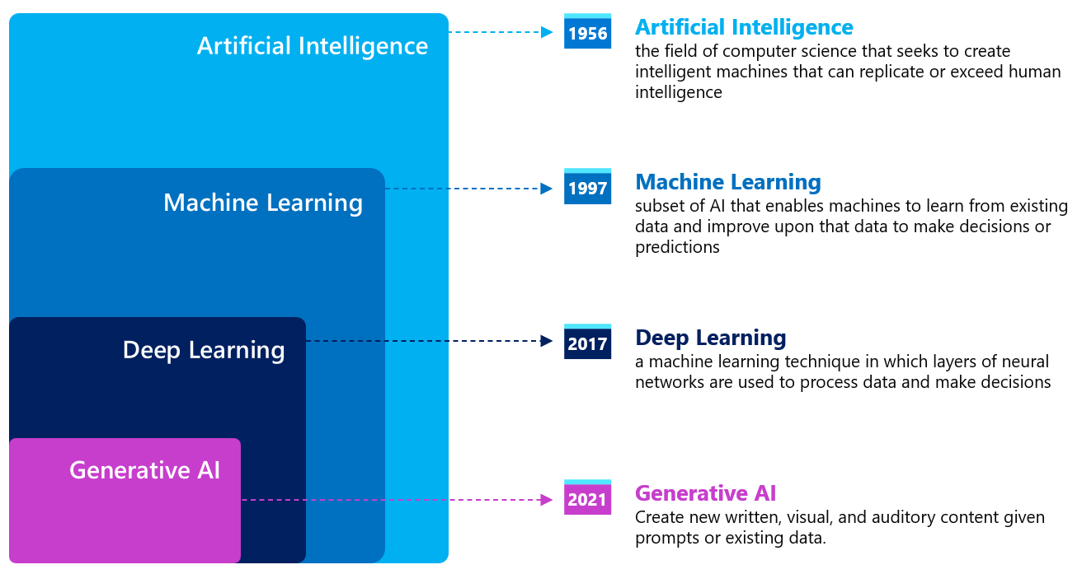

**What is GenAI?**

* Generative AI refers to a subset of artificial intelligence (AI) that can **generate** **new, original content** rather than just analyzing and acting on existing data.
* It does this by learning patterns from large datasets and then **creating something new** based on those learned patterns.
* It uses advanced machine learning techniques, especially **neural** **networks**. Note that *most* (but not all) generative AI models are based on deep learning training techniques, so we show generative AI as a subset of deep learning.

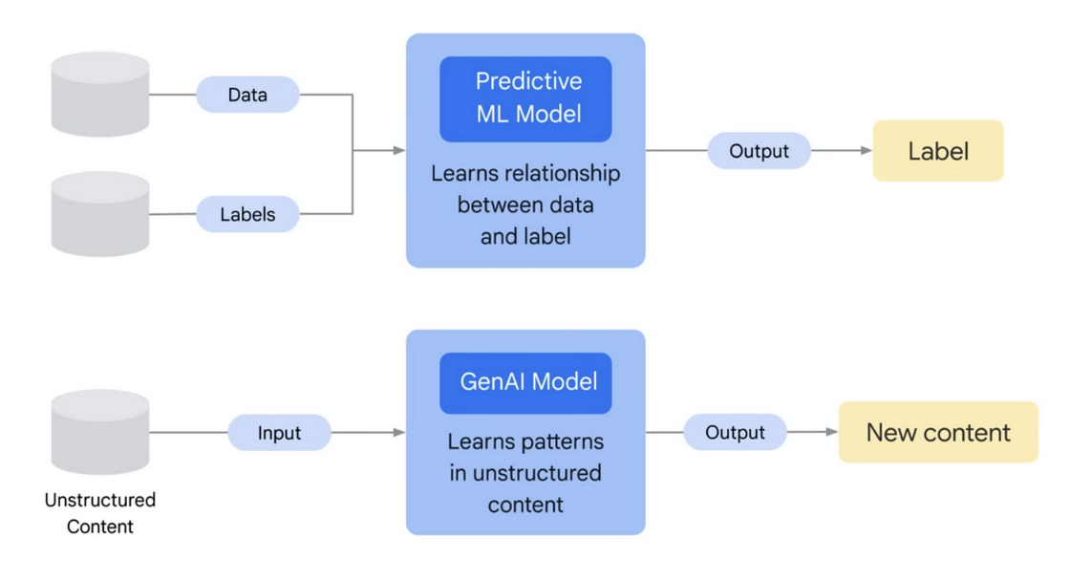

****What GenAI can do?****

1. **Content Creation** 
   * **Text Generation**: Write articles, summaries, and even technical documentation.
   * **Creative Writing**: Generate stories, poetry, and scripts.
   * **Code Generation:** Helps write, debug, or optimize code.
   * **Documentation**: Create technical and non-technical documentation.
2. **Translation and Summarization:**
   * **Language translation** (real-time or written text).
   * **Summarizes** large documents into concise information.
3. **Design & Art:**
   * **Image Creation:** Generate artwork, designs, or visuals based on textual descriptions.
   * **Video Generation:** Create synthetic videos, animations, or edits.
   * **UX/UI Prototyping**: Aid in designing user interfaces and experiences.
4. **Audio Generation:**
   * **Text-to-Speech:** Converts text into natural-sounding audio.
   * **Voice Cloning:** Mimics specific voices.
   * **Music**: Can create music

And lot more…

****Key technologies behind GenAI****

1. **Machine Learning**

* **Supervised Learning**: For tasks like text classification and labeling.
* **Unsupervised Learning**: For clustering and pattern discovery, aiding in generative tasks.
* **Reinforcement Learning**: Used in fine-tuning generative models like RLHF (Reinforcement Learning from Human Feedback) in ChatGPT.

1. **Deep Learning Neural Networks:** The backbone of most GenAI models.
   * **Feedforward Neural Networks**: For straightforward tasks like regression and classification.
   * **Convolutional Neural Networks (CNNs):** Primarily for image and video generation.
   * **Recurrent Neural Networks (RNNs):** For sequential data like text and audio (less common now with transformers).
   * **Deep Learning Transformers For text generation and image and speech processing**
2. **Large Language Models (LLMs):** Models trained on massive datasets to understand and generate text.

* Examples: **OpenAI’s GPT-4, Google’s Gemini, Meta’s LLaMA, Anthropic’s Claude.**
  + GPT (Generative Pretrained Transformer)
  + BERT (Bidirectional Encoder Representations from Transformers).

1. **Computer Vision**
   * **Generative Adversarial Networks (GANs)**: Used for generating images and videos.

**Some open-source GenAI models available include:**

* **GPT-2** and **GPT-3** (via OpenAI's API)
* **BERT** (Bidirectional Encoder Representations from Transformers) by Google
* **T5** (Text-to-Text Transfer Transformer) by Google
* **BLOOM** by BigScience
* **OPT** (Open Pretrained Transformer) by Meta
* **PaLM** (Pathways Language Model) by Google (open for research use)
* **LLaMA** (Large Language Model Meta AI) by Meta
* **ELEUTHERAI GPT-Neo** and **GPT-J** (by EleutherAI)
* **StableLM** by Stability AI

****History and Evolution of GenAI****

* **1950s**: Alan Turing proposed the concept of machine learning
* **1980s**: Neural networks gained popularity with the **backpropagation algorithm**, enabling computers to learn patterns in data.
* **1990s**: Generative models began as rule-based systems, primarily used for text generation.
* **2000s**: Introduction of **Bayesian Networks** and **basic autoencoders** for probabilistic data generation.
* **2012**: Deep learning gained prominence with breakthroughs in image recognition using convolutional neural networks (CNNs).
* **2014**: Ian Goodfellow introduced **Generative Adversarial Networks (GANs)**, a landmark moment in GenAI.
* **2015**: Google introduced the **Seq2Seq model**, improving text translation and summarization.
* **2017**: Google released the **Transformer architecture**, which revolutionized natural language processing (NLP).
* **2018**: OpenAI introduced **GPT-1**, the first generative pre-trained transformer model.
* **2019**: GPT-2 demonstrated the potential of large-scale generative models, capable of producing human-like text.
* **2020**: GPT-3 launched with 175 billion parameters, showing unprecedented performance in text generation.
* **2021**: OpenAI introduced **DALL·E**, a model capable of generating images from textual descriptions.
* **2022**: Models like **ChatGPT** showcased real-time conversational abilities. **MidJourney** and **Stable Diffusion** advanced text-to-image generation
* **2023 and Beyond**: ChatGPT gained widespread adoption. Advancements in multimodal AI models (e.g., combining text, image, and audio generation). Ethical and responsible GenAI development became a focus to address societal concerns.

****Applications of GenAI****

**For businesses GenAI can help in:**

* Speeding up creative and repetitive processes and delivering differentiated customer experiences.
* Reduces costs in content production and can also generate new revenue streams
* Modernize internal processes.

**Use cases:**

* **Marketing and Advertising**: Automated content creation for campaigns.
* **Entertainment**: Generating scripts, music, or special effects.
* **Education**: Creating personalized learning materials.
* **Healthcare**: Designing molecules for drug discovery.
* **Customer Support**: Developing virtual assistants and chatbots.

**Challenges of GenAI**

* **Cultural Shift**: Redefining how content is created and consumed.
* **Bias and Fairness:** AI systems learn from the data they are trained on, which can introduce biases if the data is not diverse or representative.
* **Creativity vs. Authenticity:** While AI can generate new content, it may lack true creativity or understanding and could produce content but is incorrect or misleading information.
* **Plagiarism and Copyright Issues**: Challenges in intellectual property ownership.
* **Ethical Concerns:** AI-generated content, especially deepfakes or fake news, can be misused, raising concerns about authenticity and trust.